Classification Modelling for Decision Support
Entire Orange Workflow
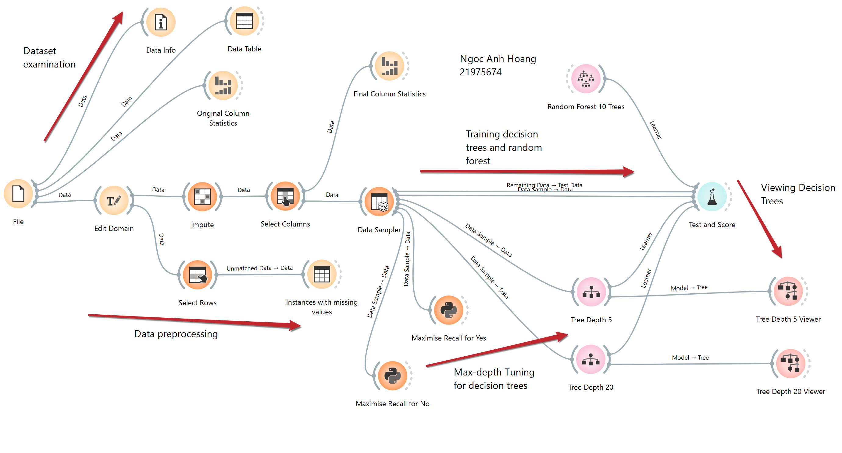
- Data Exploration and Pre-processing
- Dataset overview
This dataset contains health survey data used to study diabetes risk, with 7,000 individual records (rows) and 18 features (excluding the Index) covering demographic, lifestyle, and health-condition information (Figure 1). The target feature is Diabetes, a binary variable (0 = no diabetes, 1 = prediabetes or diabetes) that indicates whether a respondent has been diagnosed with diabetes or prediabetes, making this a binary classification problem.
Most of the predictor features, such as High_Chol, Chol_Checked, Smoker, Stroke, Heart_Disease_or_Attack, Physical_Activity, Fruits, Veggies, Heavy_Alcoholic, Has_Healthcare, Walk_Difficult, and Gender, are categorical/binary (0/1), since they represent yes/no health behaviours, conditions, or presence/absence states (except for Gender, which represents Female/Male). BMI, Nbr_Days_Poor_Mental, and Nbr_Days_Poor_Physical are numerical variables, as they measure a quantity (body mass index) or a count of days (0–30) on a continuous scale. Age_Group and Education_Level are ordinal categorical variables, since their numeric codes represent ranked categories.
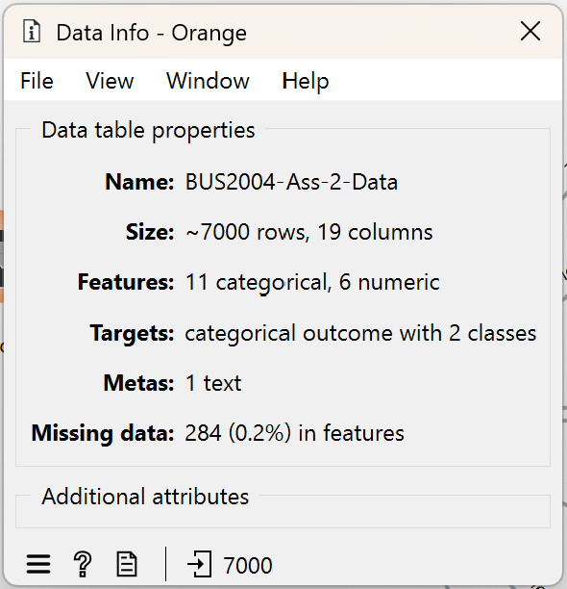
Figure 1. Dataset overview.
- Problems found in preprocessing steps and solutions
- Inconsistent values in categorical features and incorrect feature types are treated using the Edit Domain widget.
Four features were initially misclassified: Index was identified as numeric rather than string, while Age_Group, Education_Level, and Chol_Checked were identified as numeric rather than categorical. Treating categorical or identifier variables as numeric can mislead algorithms into assuming false mathematical relationships between values, reducing analytical accuracy and interpretability (García et al., 2015). These four attributes were therefore reclassified into their correct data types, as shown in Figure 2.
The Index feature is a unique identifier that distinguishes each instance in the dataset, which will be removed before training the model. Chol_Checked variable contained inconsistent values although they have the same meaning (0 is No and 1 is Yes), therefore, they were transformed to the same values and merged together (Figure 2). Values in other categorical features with 1,0 coding (High_Chol, Smoker, Stroke, Heart_Disease_or_Attack, Physical_Activity, Fruits, Veggies, Heavy_Alcoholic, Has_Healthcare, Walk_Difficult, Gender, Diabetes) were also changed to Yes, No (or Female/Male for Gender) to have meaningful values. Age_Group and Education_Level were also intended to be recoded into their meaningful category labels; however, this could not be completed due to errors encountered in Orange. As a result, their original numeric values were retained, and interpretation of these features will be approached with caution.
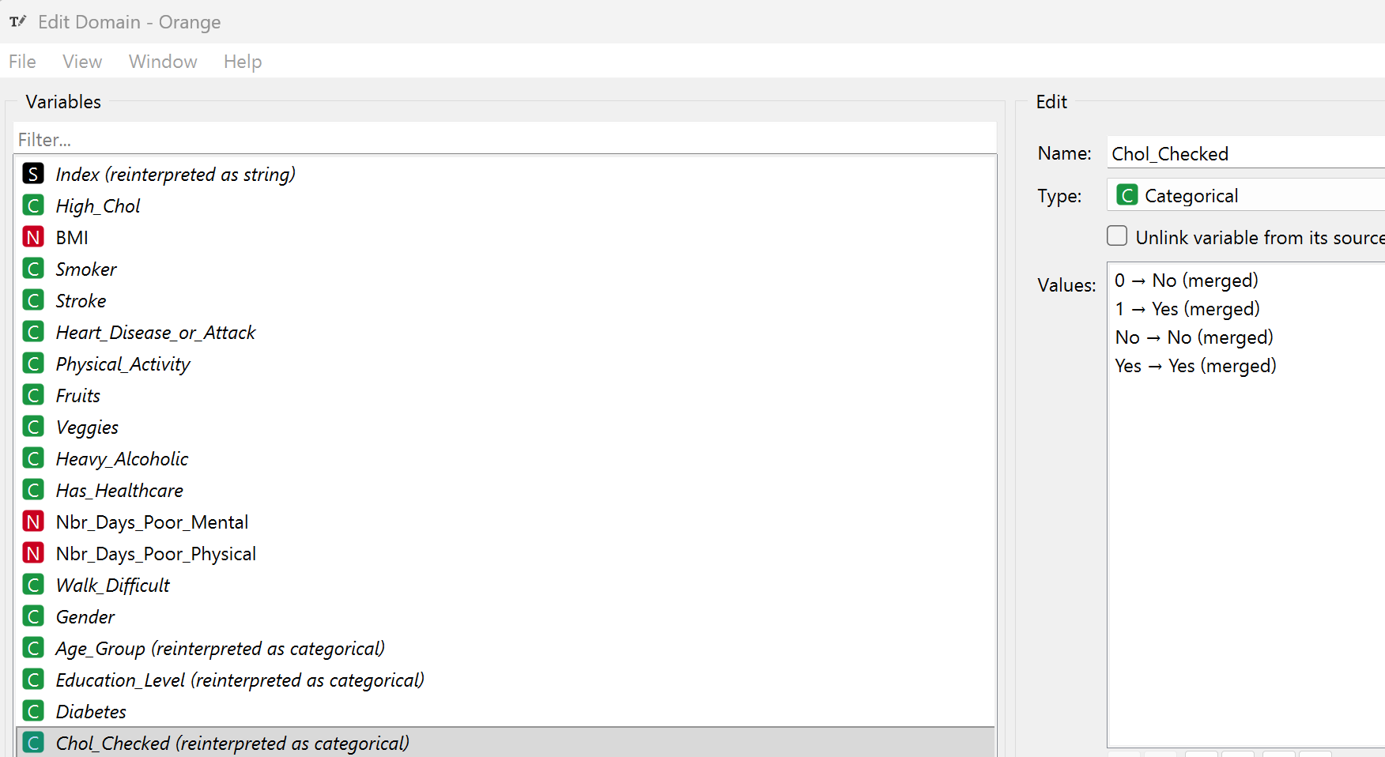
Figure 2. Edit Domain Settings.
- Missing data (284 or 0.2% overall) were treated using the Impute widget
There are 2 features with missing data: 3% or 219 instances with missing data in Nbr_Days_Poor_Mental feature, which is the record of Days of Poor Mental Health in Past Thirty Days; 1% or 65 instances with missing data in the Has_Healthcare feature, which are the record of Has Any Health Care Coverage.
Instances with missing data were examined using the Select Rows widget to identify unmatched rows based on the condition shown in Figure 3. This inspection revealed no clear relationship between features that could support imputing missing values through a fixed value or calculation, while using mode or mean imputation risked distorting the original data distribution. Consequently, a model-based imputer (Simple Tree) was applied instead (Figure 4), as it estimates missing values by learning patterns from other values, helping preserve relationships between variables and reduce bias compared to simpler imputation methods (Perini & Nikolic, 2024).
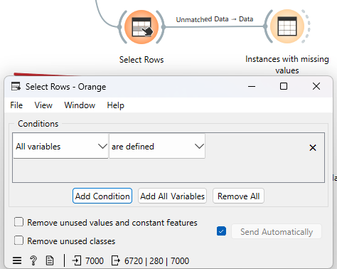
Figure 3. Examining the instances with missing values.
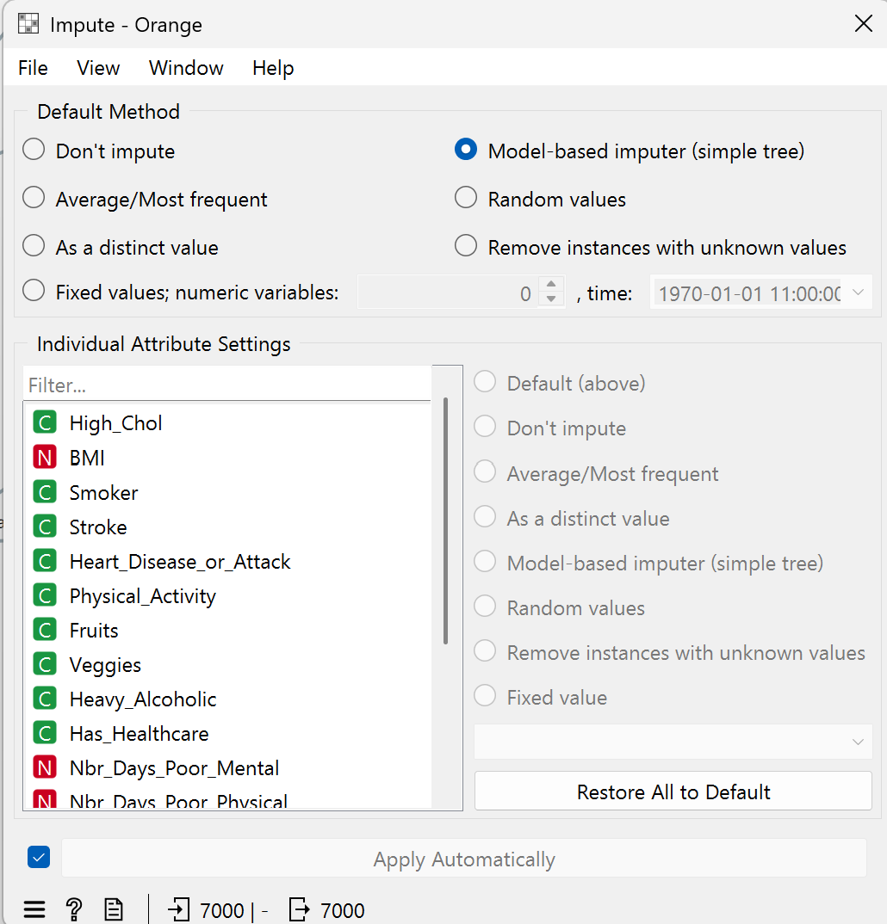
Figure 4. Imputation settings.

- Data Distribution
First, there are no impossible values (such as negative values in numeric features or values that are not 0,1 in binary features). The target variable, Diabetes, shows a strongly imbalanced distribution, with approximately 86% of respondents classified as "No" (No diabetes) and only about 14% classified as "Yes". This heavy skew toward the negative class means a model could achieve high accuracy simply by predicting "No" for every instance, without actually learning meaningful patterns from the data. As a result, accuracy alone would be a misleading evaluation metric, and greater emphasis should be placed on precision, recall, and F1-score, particularly for the minority "Yes" class, to properly assess model performance. This imbalance also suggests that resampling techniques (oversampling the minority class or undersampling the majority class) should be considered; however, this will be ignored in this project.
Most respondents cluster around the lower ranges, with a smaller number of high-BMI outliers pulling the mean upward. BMI has a mean (28.44) noticeably higher than its mode/median (27), with a visibly right-skewed distribution. Next, most respondents report no poor-health days, while a smaller subset reports many, creating a strong right-skew. Nbr_Days_Poor_Mental and Nbr_Days_Poor_Physical both have a mode and median of 0 but noticeably higher means (3.14 and 4.20), with high dispersion (2.31 and 2.07). Moreover, the sample leans toward middle-aged and older adults and highly educated people. Age_Group shows a roughly unimodal, slightly right-skewed spread across categories, with a mean around 9 (or the 55–59 age group). Education_Level is left-skewed (with mode of 6, "college graduate")
Chol_Checked and Has_Healthcare are heavily skewed toward "Yes," which is expected since regular cholesterol checks and access to healthcare coverage are common behaviours among survey respondents. Stroke, Heavy_Alcoholic, Heart_Disease_or_Attack, and Walk_Difficult are heavily skewed toward "No," which is expected given these represent relatively rare conditions or behaviours within the general population.

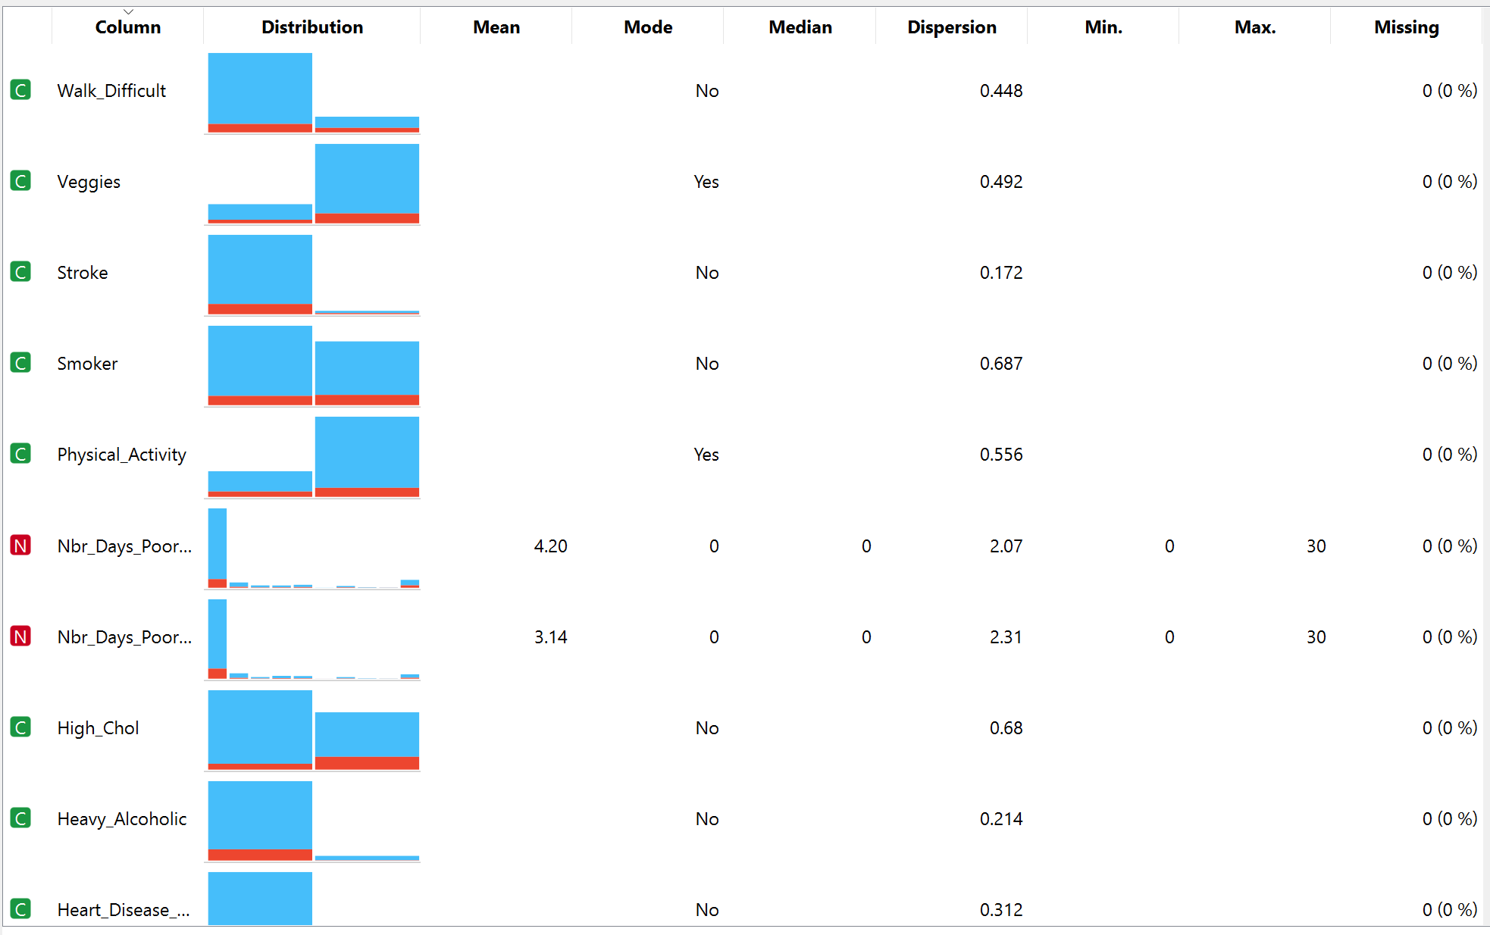
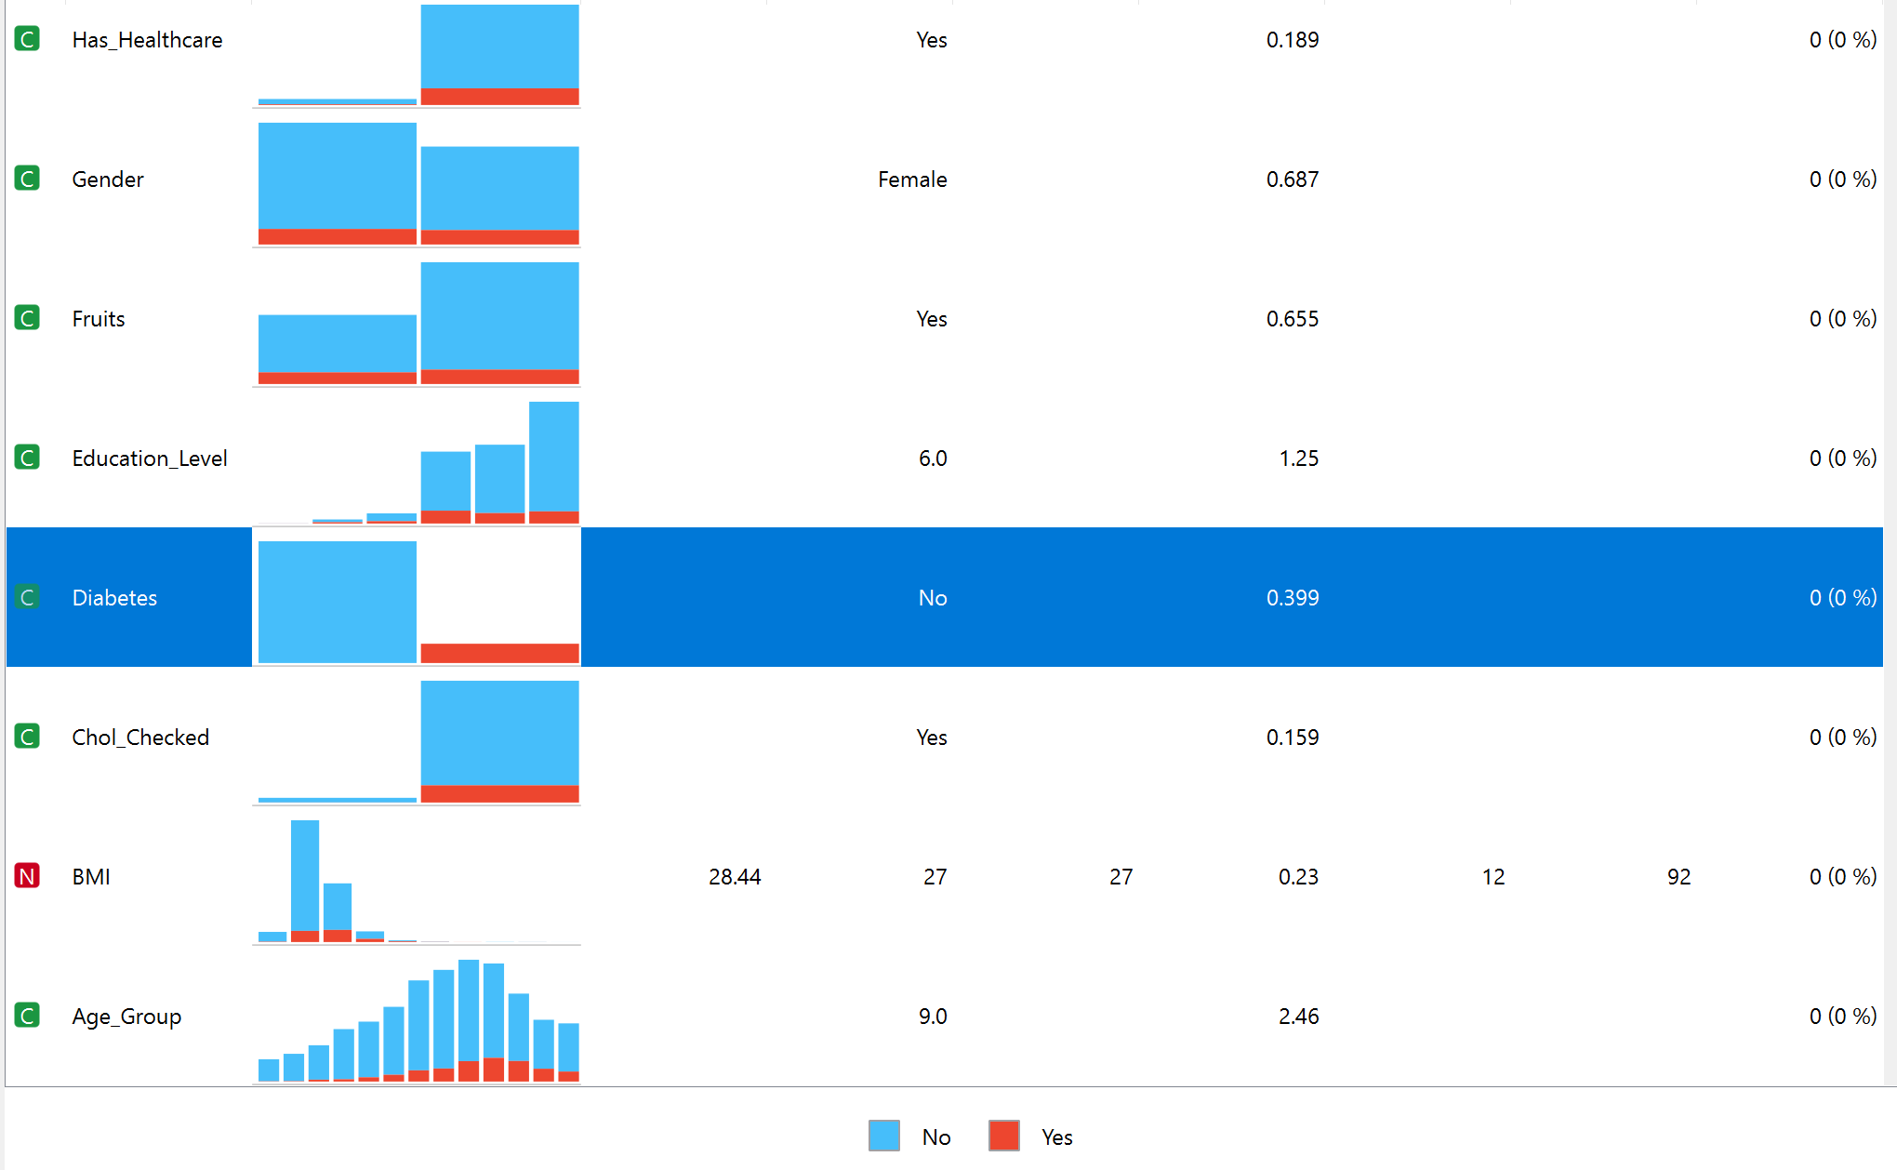
Figure 5. Data distribution.
- Model Development and Improvement
- Irrelevant column (Index) was removed using the Select Columns widget.
The Index feature is a unique numerical identifier that distinguishes each instance in the dataset but carries no meaningful information about the respondents' health characteristics. Therefore, it holds no predictive value, and including this in the model would risk introducing noise (Saveliev et al., 2025). So it was removed from the model. All other features (18 features including the target) were kept.
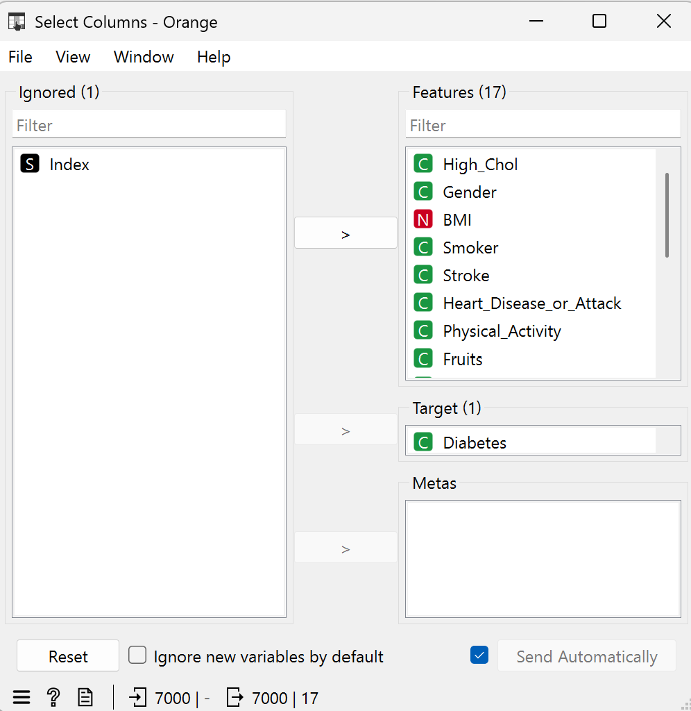
Figure 6. Select Columns Settings.
- Data sampling using Data Sampler widget.
After preprocessing, 18 features (including the target feature) and 7000 rows were used for data sampling. The dataset was split using the Data Sampler widget with a fixed proportion of 70%, producing 4,900 instances for training and 2,100 for testing (Figure 7). Two options were enabled during sampling: Replicable (deterministic) sampling, which fixes the random seed so that the same split can be reproduced in future runs, ensuring consistency and reliability when re-evaluating or comparing models; and Stratify sample (when possible), which preserves the original class proportions of the target variable (Diabetes) in both the training and test sets, preventing the minority class from being underrepresented or excluded (Lee & Ahn, 2023), which is especially important given the class imbalance identified earlier.
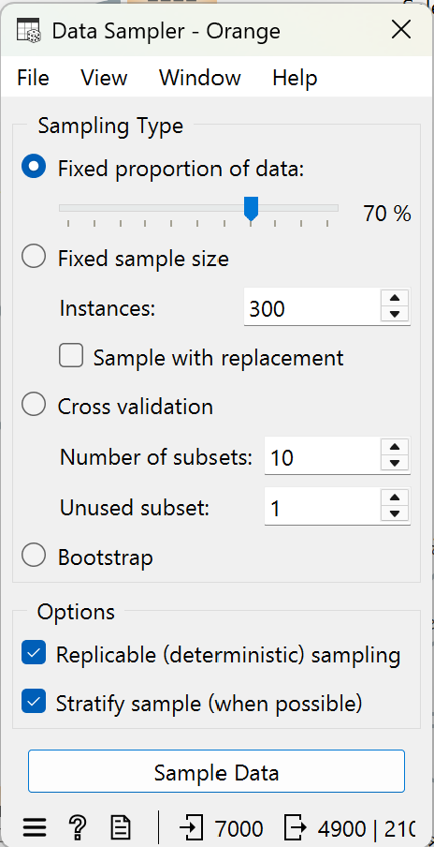
Figure 7. Data Sampler Settings.
Using the 4,900 instances for training and the 18 features as inputs, two classification models (a decision tree with a maximum depth of 5, and a random forest with 10 trees) were built (Figure 8). For the decision tree, depth is limited to 5 with a minimum of 2 instances per leaf and no splits on subsets under 5, keeping the tree simple, interpretable, and less prone to overfitting. The binary structure suits the mostly binary/categorical features, and the 95% majority stopping rule balances purity with readability. For the random forest, 10 trees offer a lightweight ensemble that reduces variance over a single tree without heavy computation. Depth (5) and minimum subset size (5) match the single tree for fair comparison. Replicable training was ticked to ensure the model produces consistent, reproducible results across runs. “Balance class distribution” was left unchecked, as it could reduce overall model performance; this is likely because forcing artificial balance can distort the true class relationships the forest learns from (Faiz et al., 2026).
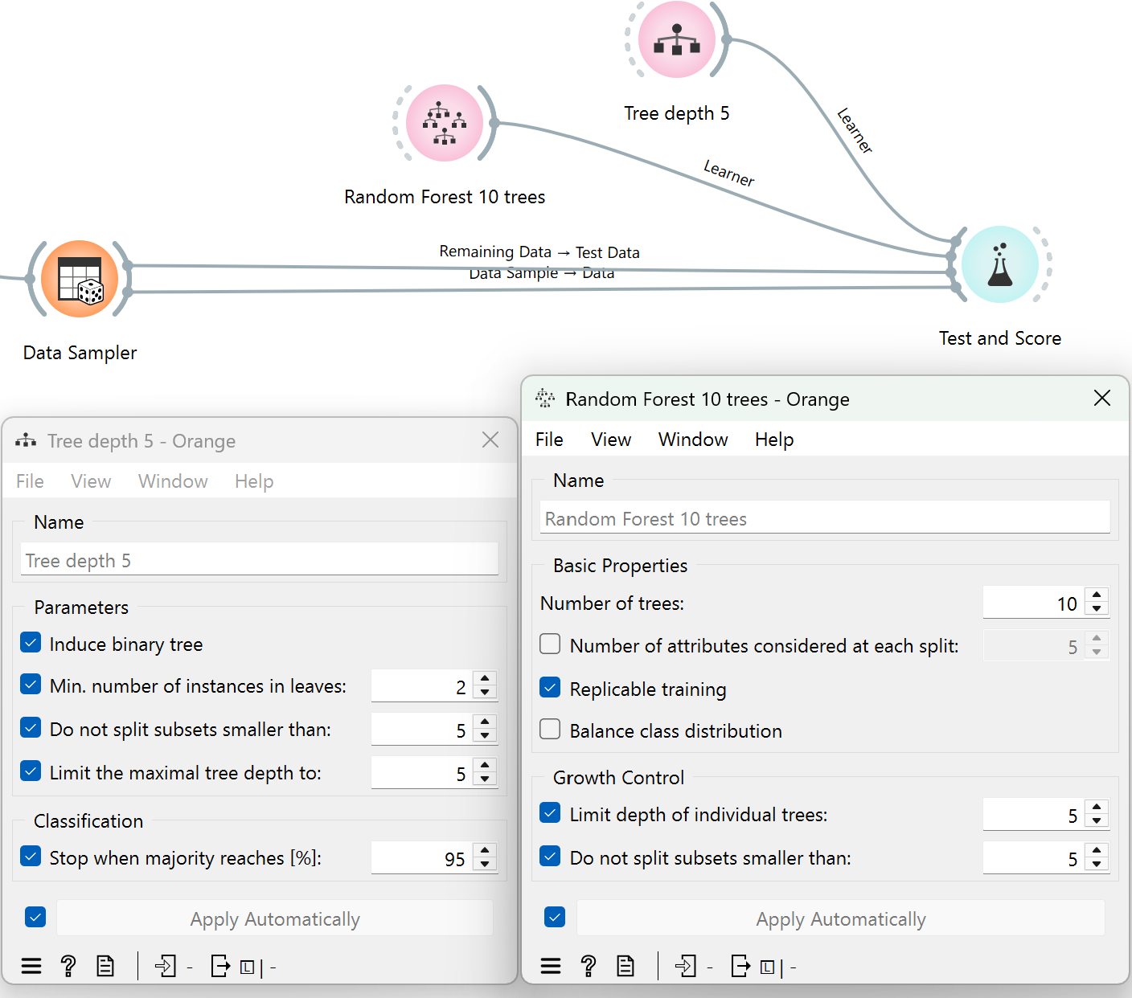
Figure 8. Decision Tree and Random Forest settings
- Test results on Test and Score widget
On the test data (Figure 9), Tree depth 5 scored a slightly higher F1 (0.820) than Random Forest 10 trees (0.802), with a similar pattern in precision (0.814 vs. 0.787) and recall (0.860 vs. 0.861). F1 combines precision (how many predicted "diabetes" cases were actually correct) and recall (how many actual diabetes cases the model caught) into one score. It shows whether the model can balance between two types of errors: false positives (predicting "diabetes" for someone who doesn't have it) and false negatives (missing an actual diabetes/prediabetes case). However, because the evaluation target was set to average over both classes, all four metrics are weighted averages across "No" and "Yes”. As Orange's documentation explains, when this option is selected, scores are computed separately for each class as the target class, then combined into a single weighted average based on class size (Orange Data Mining, n.d.).
For Tree depth 5, the reported precision (0.814) and recall (0.860) were computed with "(None, show average over classes)" selected, meaning these figures are weighted averages across both classes. In practical terms, a recall of 0.860 means that when recall is calculated separately for "No" and for "Yes," then combined into one number weighted by how many people fall into each class, the blended result comes out to 0.860. Since "No" makes up about 86% of the data, this blended figure is pulled heavily toward however well the model performs on "No" specifically, and can look high even if performance on "Yes" is poor. The same logic applies to the 0.814 precision figure.
This distinction matters because recall on the "Yes" class is the metric of greatest practical importance here: a missed diagnosis (false negative) allows the condition to progress untreated, whereas a false alarm simply leads to further low-cost testing (Saito & Rehmsmeier, 2015). However, the strong overall recall shown in Figure 9 is therefore misleading on its own: it reflects performance on the easy majority class ("No") while masking a more serious shortfall in catching true diabetic/prediabetic cases ("Yes"). Given this, the small F1 gap between the two models at the aggregate level should not be treated as a meaningful basis for preferring one model over the other, since neither the F1 nor the aggregate precision/recall values isolate performance on the class that matters most for this screening task. This confirms the need to examine class-specific recall directly, which is addressed through the Python Script analysis in the next section.

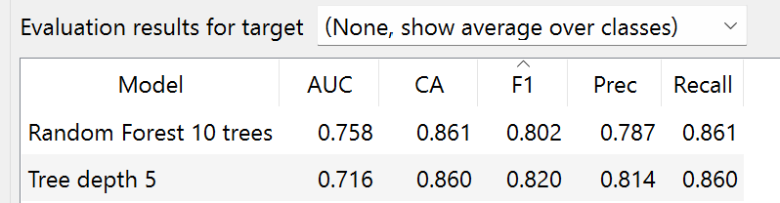
Figure 9. Results using Test on test data
- Python Script for tree max-depth tuning.
A Python Script widget was added to the workflow to search for the best tree max-depth based on the best recall. The script used GridSearchCV with a DecisionTreeClassifier pipeline and 5-fold stratified cross-validation (StratifiedKFold) to evaluate recall across a range of candidate max-depth values: [5, 7, 8, 9, 10, 12, 13, 14, 15, 20, 22, 25, 27, 30, 32, 33]. This range was chosen to densely sample lower depths, where recall changes most rapidly, while sparsely sampling higher depths to check whether performance plateaus or declines due to overfitting; the lower bound of 5 was also kept consistent with the earlier single-tree baseline for comparability. The grid search identified max-depth = 20 as optimal (Figure 10), achieving a mean cross-validated recall of 0.304. As shown in the results table, recall increased steadily from depth 5 (0.093) up to depth 20 (0.304), before plateauing and slightly declining at greater depths (e.g., 0.293 at depth 30–33). This shows that deeper trees beyond 20 provide no further benefit and risk overfitting to the training folds without improving generalisation. The best-performing configuration (max-depth = 20) was then used as a new tree’s hyperparameter setting to compare its train, test, and validation performance against the baseline models (Figure 11)
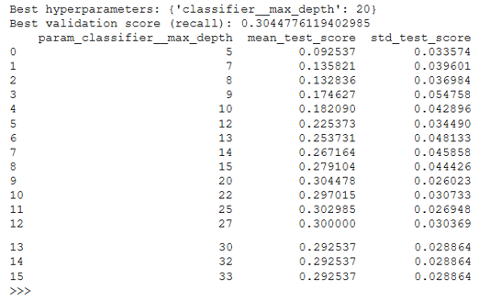
Figure 10. Result from Python Script 1: Maximise Recall for Yes
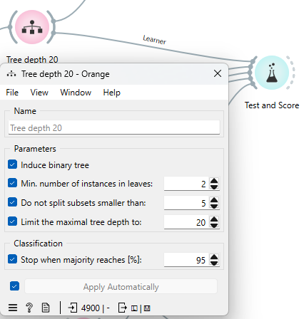
Figure 11. Tree depth 20 settings.
The gap between the validated recall from Python (~0.30) and Orange's Test and Score recall (~0.86) comes from how each tool calculates the metric (Figure 10, 12). Orange's recall, with "average over classes" selected, is a weighted average across both classes. In contrast, scoring='recall' in GridSearchCV computes binary recall for class 1 by default. And since "Yes" (the minority class) appears to be encoded as class 1 (Figure 13), the ~0.30 score reflects the model's true, much weaker performance at identifying "Yes" cases specifically, due to limited minority-class examples and the model's bias toward the majority class (Chawla et al., 2002).
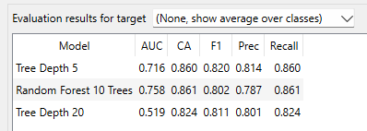
Figure 12. Test and Score results with test on test data.
A revised Python Script widget was used to search for the best tree max-depth using pos_label=0, this time explicitly scoring recall for the "No" class (confirmed as class code 0), rather than the default class 1 ("Yes") used previously. Using the same 5-fold stratified cross-validation and max-depth range as before, the grid search identified max-depth = 5 as optimal, achieving a mean cross-validated recall of 0.977 for the "No" class. The results table shows that recall for "No" is highest at the shallowest depth (0.977 at depth 5) and steadily declines as max-depth increases, dropping to approximately 0.867 by depth 20 and beyond. This is the inverse pattern to the earlier "Yes"class search, and reflects the same underlying cause: since "No" is the majority class, a shallow tree can achieve very high recall for it simply by defaulting most predictions toward "No". In contrast, deeper trees begin creating more specific splits that correctly capture minority "Yes" cases at the expense of some "No" recall. This confirms that the choice of max-depth involves a trade-off between the two classes, and reinforces the importance of selecting the tuning measure (and target class) based on the “Yes” class, as errors for this class are more costly.
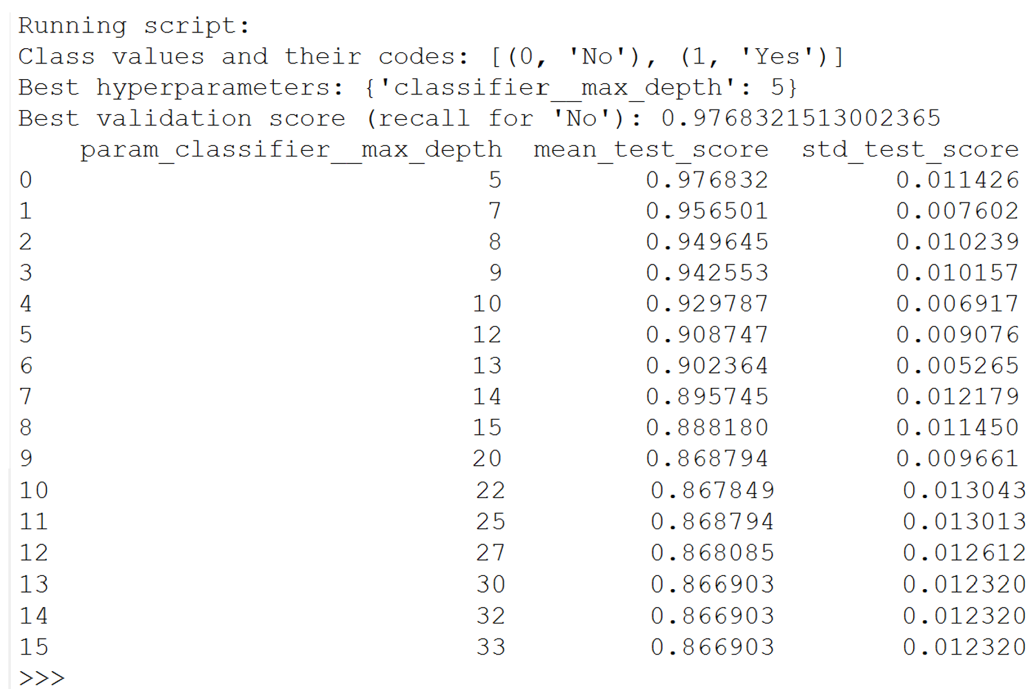
Figure 13. Result from Python Script 2: Maximise Recall for No
Depth 20's train scores look far stronger across all metrics, but this advantage collapses on the test set, with AUC falling from 0.934 to 0.519 (barely above random), and F1/Recall also drop. Depth 5 barely changes between train (AUC 0.781) and test (AUC 0.716), and even slightly outperforms depth 20 on test F1 on test data (0.820 and 0.811). This train–test gap for depth 20 is a clear sign of overfitting: the deeper tree memorises training-specific patterns rather than learning generalisable rules, so its performance does not transfer to new data.
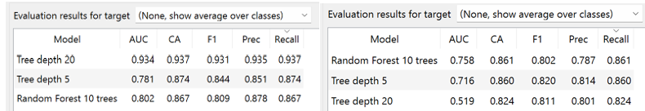
Figure 14. Test on Train data vs Test data (average over classes)
The grid search's recall figures above (0.977 for "No" at depth 5, 0.304 for "Yes" at depth 20) come from 5-fold cross-validation on the training data, used purely to select the best max-depth. Figure 15 instead comes from evaluating the final trained trees on the held-out test set, so they are expected to differ slightly from the cross-validated estimates. Depth 5 achieves very high recall for "No" (0.979) but almost fails on “Yes" (0.105), while depth 20 doubles "Yes" recall (0.213) at some cost to "No" recall (0.921). However, this high "No" recall at depth 5 should be interpreted cautiously rather than taken as strong model skill: because the dataset (especially after stratified sampling) remains ~86% "No", a model can achieve high recall on the majority class largely by defaulting most predictions toward it, inflating apparent performance without genuinely learning discriminative patterns, which is also known as the "accuracy paradox" in imbalanced classification (Galar et al., 2011). This means part of depth 5's strong "No" recall reflects the class's dominant base rate rather than model skill alone, reinforcing that its "good" performance is partly an artefact of the imbalance rather than solely from correct classification of the class.
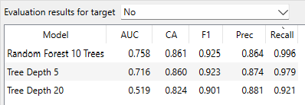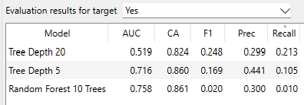
Figure 15. Test on Test data of No class vs Yes class
Overall, depth 20 overfits as its strong train performance doesn't hold on test data, though it does improve minority-class ("Yes") recall. Depth 5 generalises far better and comfortably captures the majority "No" class, though this is partly inflated by class imbalance rather than pure model skill, and it performs poorly on "Yes". Given the priority of detecting true diabetes cases, depth 5 remains the more suitable choice, as it is reliable and least overfit; however, its weak "Yes" recall is a limitation if avoiding missed non-diabetic misclassifications also matters. Although depth 20 gives the strongest recall for the "Yes" class, this comes at the cost of significant overfitting as the model memorises minority-class noise, undermining its reliability on unseen data. No single depth can therefore be confidently recommended. Instead, the class imbalance should be addressed at the data level (oversampling, undersampling, or class-weighting) before re-tuning tree depth, which is likely to yield a more robust model than depth adjustment alone.
- The important attributes based on 2 decision trees.
Both trees split first on High_Chol, then BMI, confirming these as the two most influential predictors of diabetes/prediabetes risk in this dataset. Respondents with high cholesterol and higher BMI are consistently routed toward higher-risk ("Yes") branches at the top of both trees. This aligns with established clinical understanding that high cholesterol and elevated BMI are major risk factors linked to insulin resistance and diabetes.
At the levels visible here, both trees also share the same subsequent splits, BMI thresholds branching into Age_Group, Walk_Difficult, and Education_Level, before reaching further BMI-based divisions. This consistency across the two models, despite their different depth settings, adds confidence that High_Chol, BMI, Age_Group, Walk_Difficult, and Education_Level are genuinely predictive of diabetes risk.
Beyond this shared top structure, the depth-20 tree continues splitting further than depth 5, growing into a larger and more fragmented model. This additional depth is consistent with the earlier finding that depth 20 achieves stronger training performance but weaker generalisation to the test set, as the extra splits allow the model to isolate increasingly small, specific subsets of the data rather than capturing broader patterns.

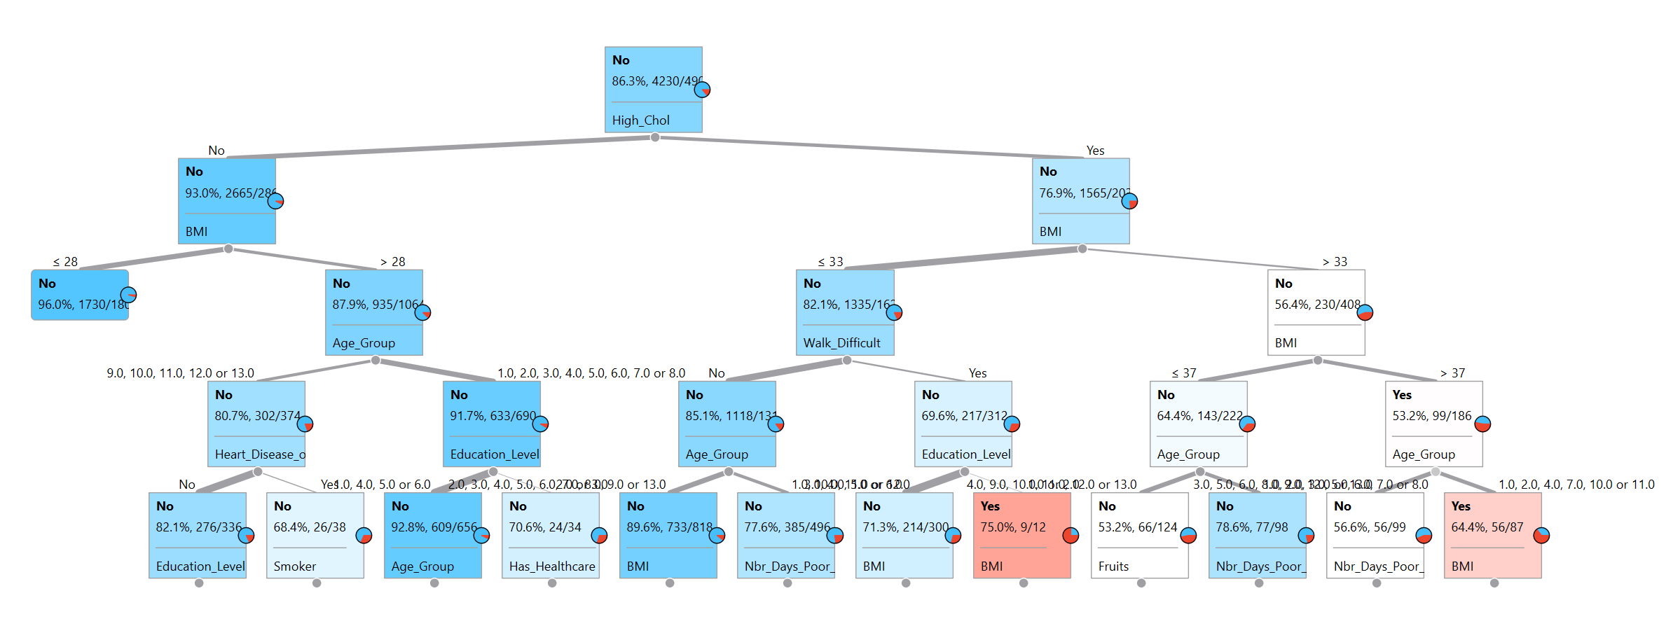
Figure 16. Tree Depth 5 viewer (viewing depth = 5)
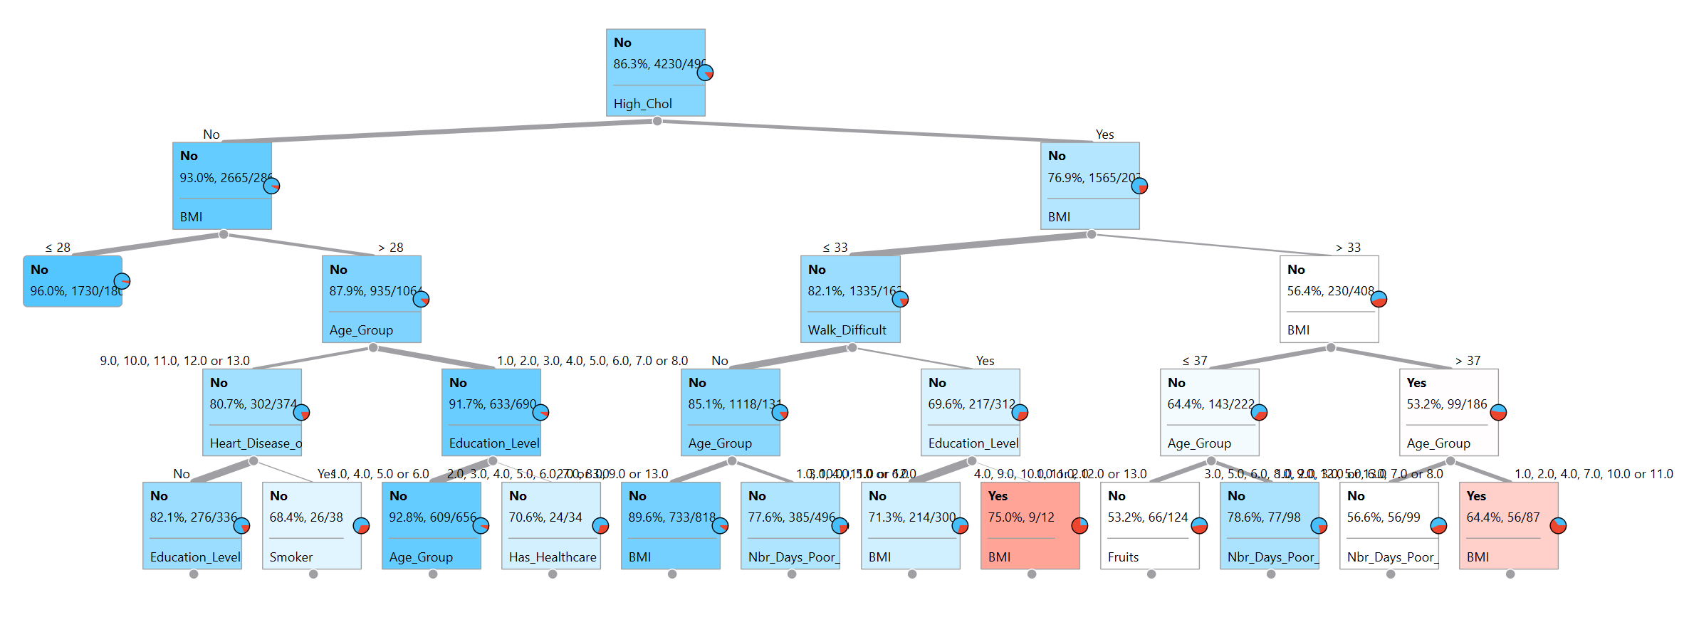
Figure 17. Tree Depth 20 viewer (viewing depth = 5)

Reference
Chawla, N. V., Bowyer, K. W., Hall, L. O., & Kegelmeyer, W. P. (2002). SMOTE: Synthetic minority over-sampling technique. Journal of Artificial Intelligence Research, 16, 321–357.
Faiz, N., Iftikhar, S., Jan, S., Hamraz, M., Aamir, M., & Khan, D. M. (2026). Pruning tree forest and re-sampling for class imbalanced problem. Scientific Reports, 16, Article 8087. https://doi.org/10.1038/s41598-026-38320-1
Galar, M., Fernández, A., Barrenechea, E., Bustince, H., & Herrera, F. (2011). A review on ensembles for the class imbalance problem: Bagging-, boosting-, and hybrid-based approaches. IEEE Transactions on Systems, Man, and Cybernetics, Part C, 42(4), 463–484. https://doi.org/10.1109/TSMCC.2011.2161285
García, S., Luengo, J., & Herrera, F. (2015). Data preprocessing in data mining. Springer.
Lee, H., & Ahn, S. (2023). Improving the performance of object detection by preserving label distribution. arXiv. https://arxiv.org/abs/2308.14466
Orange Data Mining. (n.d.). Test and Score. Retrieved September 18, 2026, from https://orangedatamining.com/widget-catalog/evaluate/testandscore/
Perini, M., & Nikolic, M. (2024). In-database data imputation. arXiv. https://arxiv.org/abs/2401.03359
Saito, T., & Rehmsmeier, M. (2015). The precision-recall plot is more informative than the ROC plot when evaluating binary classifiers on imbalanced datasets. PLOS ONE, 10(3), e0118432. https://doi.org/10.1371/journal.pone.0118432
Saveliev, E., Liu, J., Seedat, N., Boyd, A., & van der Schaar, M. (2025). Towards human-guided, data-centric LLM co-pilots. arXiv. https://arxiv.org/abs/2501.10321

